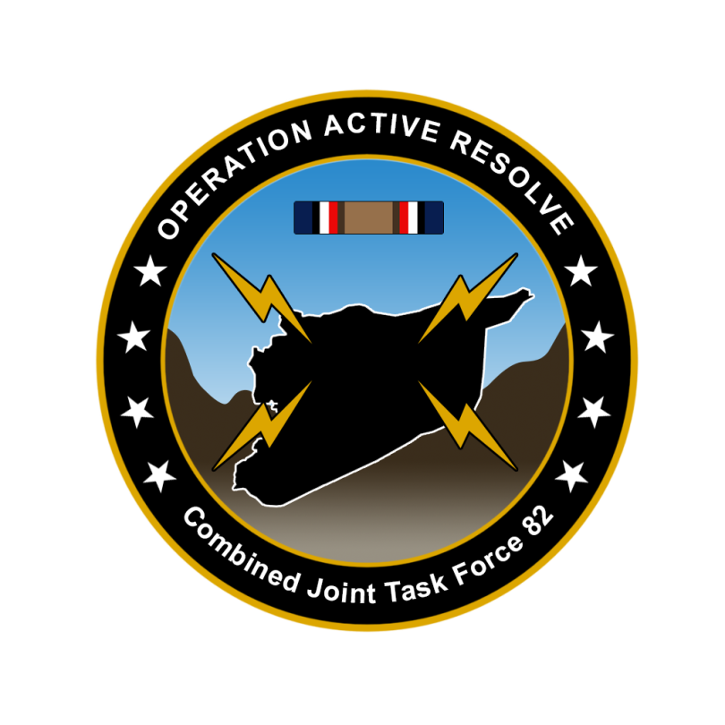

CJTF-82 OPERATION ORDER

OPERATION ACTIVE RESOLVE

# SITUATION

## General Situation

## Friendly situation

TBD

Briefly describe land, maritime, air and SOF.

## Enemy situation.

TBD

Big picture enemy situation

* Syrian major units (corps)
* Syrian Air forces and Air defenses (Big picture),
  + details to follow in Joint Air Operations Plan (JAOP)
* Terror groups
* Insurgent groups

# MISSION

CJTF-82 will deploy to the area of operations (AO) and restore Turkish and Israeli territorial integrity, once sufficient forces is available CJTF-82 will neutralize Syrian offensive capability in order to (IOT) contribute to a secure and stable environment, which will facilitate a lasting peace and render future international military presence unnecessary.

# EXECUTION

## Commander CJTF-82 intent.

### Purpose.

The purpose of this operation is to support Turkey and Israel in defeating the Syrian aggression.

### End state.

Syrian ability to conduct offensive operations in the region neutralized. Turkey and Israeli territorial integrity restored. International freedom of movement in the region restored.

## CONCEPT OF OPERATIONS

Operation Active Resolve will be conducted in 3 phases:

Phase 1: Shaping

Phase 2: Decisive action

Phase 3: Stabilization

### Phase 1: Shaping

Deploy forces to the region, building situational awareness (SA) of the situation and defend Turkey and Israel against Syrian aggression.

Set conditions for CJTF land offensive into Syrian to destroy Syrian offensive capability.

Phase ends when Syrian forces in Turkey and Israel have been defeated and Turkey and Israeli territorial integrity have been restored.

In this phase JFACC will be the supported commander.

### Phase 2: Decisive action

Attack Syrian forces within Syria in order to neutralize Syrian offensive capability

In this phase LCC will be the supported commander.

### Phase 3: Stabilization

Once Syrian offensive capability is neutralized, focus will shift to stabilize the situation and prepare for transition back to a situation where all actors respect the recognized international borders.

In this phase LCC will be the supported commander.

## OBJECTIVES

CJTF-82 have the following objectives:

1. Establish air superiority over Turkey.
2. Establish air superiority over Israel
3. Defeat Syrian forces in Turkey.
4. Defeat Syrian forces in Israel.
5. Establish air superiority over Syria.
6. Neutralize Syrian offensive capability
7. Reduce Syrian will to conduct operations in the region
8. Destroy Syrian WMD (weapons of mass destruction) capability
9. Reduce influence from terror groups in the region
10. Reduce influence from insurgent groups in the region

## TASKS:

### Land Component Command (LCC):

COM LCC will:

* Build up forces
* Defeat Syrian forces in Turkey and Israel.
* On order (O/O) conduct ground offensive into Syria in order to neutralize Syrian capability to conduct offensive operations.

### Maritime Component Command (MCC):

COM MCC will:

* Maintain sea control outside Turkey, Israel and Syria in order to prevent any interference from CJTF-82 operations.
* Secure SLOC (Sea Lines Of Communication) into Turkey and Israel.

### Joint Force Air Component Command (JFACC):

COM JFACC will:

* Establish and maintain air superiority over Turkey and Israel.
* Establish and maintain air superiority over Syria for phase 2.
* Plan, organize and execute targeting on behalf of CJTF-82.
  + Conduct AI campaign to break the Syrian will and capability to conduct offensive operations in phase 2.
* Support CJTF-82 with air support as requested throughout the operation.

### Special Operations Component Command (SOCC):

COM SOCC will conduct full spectrum special operations in order to :

* Support for CJTF-82 targeting in all phases
* Support counterinsurgency (COIN) operations
* Support for counterterrorism (CT) operations

# ADMINISTRATION AND LOGISTICS

Resupplies will primary be shipped in via sea lines of communication (SLOC). Priority resupplies may be flown in to Turkey or Israel.

Due to other major military operations taking place at the same time, certain high demand ammunition items may be temporarily unavailable.

# COMMAND AND CONTROL

CJTF-82 HQ located at Ramat David Airbase, Israel.

# ANNEXES

* CJTF-82 Target list (master target list)